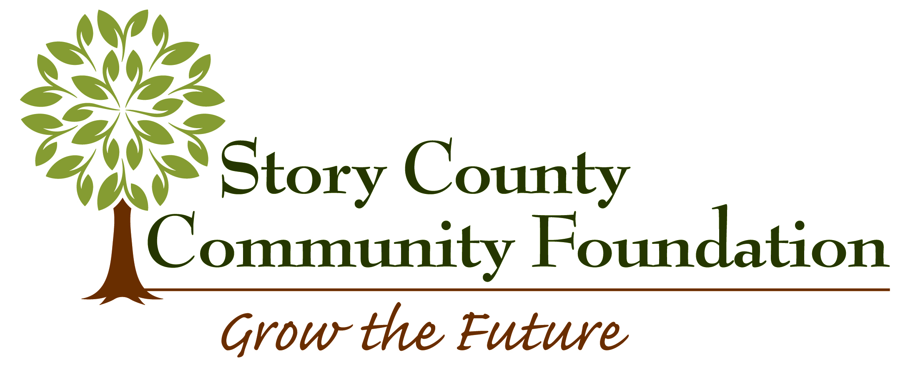
Capacity Building Grant Application

Applications must be submitted electronically
between January 1 and August 31, 2022
Grant requests of up to $2,500 will be considered

The Story County Community Foundation makes grants to nonprofits or governmental organizations with funds held under the umbrella of the Story County Community Foundation (SCCF). These grants are to help grow funds held at SCCF.

Applications are accepted January 1 – August 31

Please submit the above documents electronically (submit one PDF format file) to storycounty@storycountyfoundation.org. You will receive a message of confirmation. If you are having problems with your submission please let us know.

Organization:
Number of Employees: Number of Volunteers:

Organization Mission:

Contact person:
Position in organization:
Applying agency address:
City, State, Zip:
Phone number:
Email:
Type of applying organization: 501(c)(3) non-profit organization
local government: type
Federal tax identification number of organization:

Fiscal sponsor information is only needed if different than the applying organization.
Name of fiscal sponsor (if different than applying organization):
Federal tax identification number of fiscal sponsor:
Fiscal agency address:
City, State, Zip:
Phone number:
Email:

Project name:
Amount being requested from the Story County Community Foundation: $
Matching funds (if any): $
Total cost of project: $
Brief description of organizational need addressed by grant:

Brief description of anticipated results of the project and how it impacts the future of the
organization:

Brief description of how this grant would help grow your fund(s) at SCCF:
Project timeline:
Board commitment to the project, both financially and in terms of participation:
Project budget: Include other sources of funding and the amount requested from SCCF. Include only costs pertinent to the project. Specify how the SCCF funds would be used.
If your request is for an education purpose, explain how newly obtained information will be disseminated within your organization.

Required Documents:
- A list of the organization’s board of directors with contact information and email addresses

The project representative certifies that he/she is authorized to represent the organization applying for a grant and that the information contained in the application is accurate. He/she agrees that if a grant is awarded to the organization:

- The grant will be used for the purpose outlined in the grant award letter and may not be expended for any other purpose without prior written approval from the Story County Community Foundation
- The Story County Community Foundation has received nothing of material value in exchange for the grant
- Information about the organization and the grant may be used by the SCCF in any published materials

________________________________________________ ___________________________
Authorized Project Representative Date

Printed name:

For more information on the Capacity Building Grant application and funding process, please contact
Liz Zuercher, Executive Director at 515-232-9200 or lzuercher@storycountyfoundation.org

Application Guidelines:
Applications must include the following information:
- The organizational need addressed with the Capacity Building Grant
- Anticipated results of the project and how it impacts the future of the organization
- Timeline for the project
- Board commitment to the project, both financially and in terms of participation
- Budget, including other sources of funding and the amount requested from SCCF
  - Include only costs pertinent to the project.
  - Include the specific portion of the project SCCF funds would be used for
- A copy of the organization's 501(c)(3) designation letter
- A list of the organization's Board of Directors with contact information including e-mail addresses
- If your request is for an educational purpose, explain how newly obtained information will be disseminated within your organization

Eligibility Requirements:
The applicant must have a fund established with SCCF. Grants are made only to charitable organizations with a 501(c()3) status, or to governmental agencies. Geographically, funding is limited to projects that will significantly improve the Story County community.

SCCF will consider:
grant applications for projects that increase the ability of the organization to grow its funds held under the umbrella of SCCF. Examples of projects that could meet this criteria include (but are not limited to) those that:
- Strengthen the Board of Directors and governance of the organization, through training or assistance from an expert in the field.
- Assist in strategic thinking and planning for the future of the organization.
- Build a plan for long-term sustainability and reliable funding streams.
- Build technology systems to meet future development needs and accountability.
- Develop a marketing plan to build future sustainability.
- Or other similar use that will further the organization’s capacity to grow their funds held under the umbrella of SCCF.

