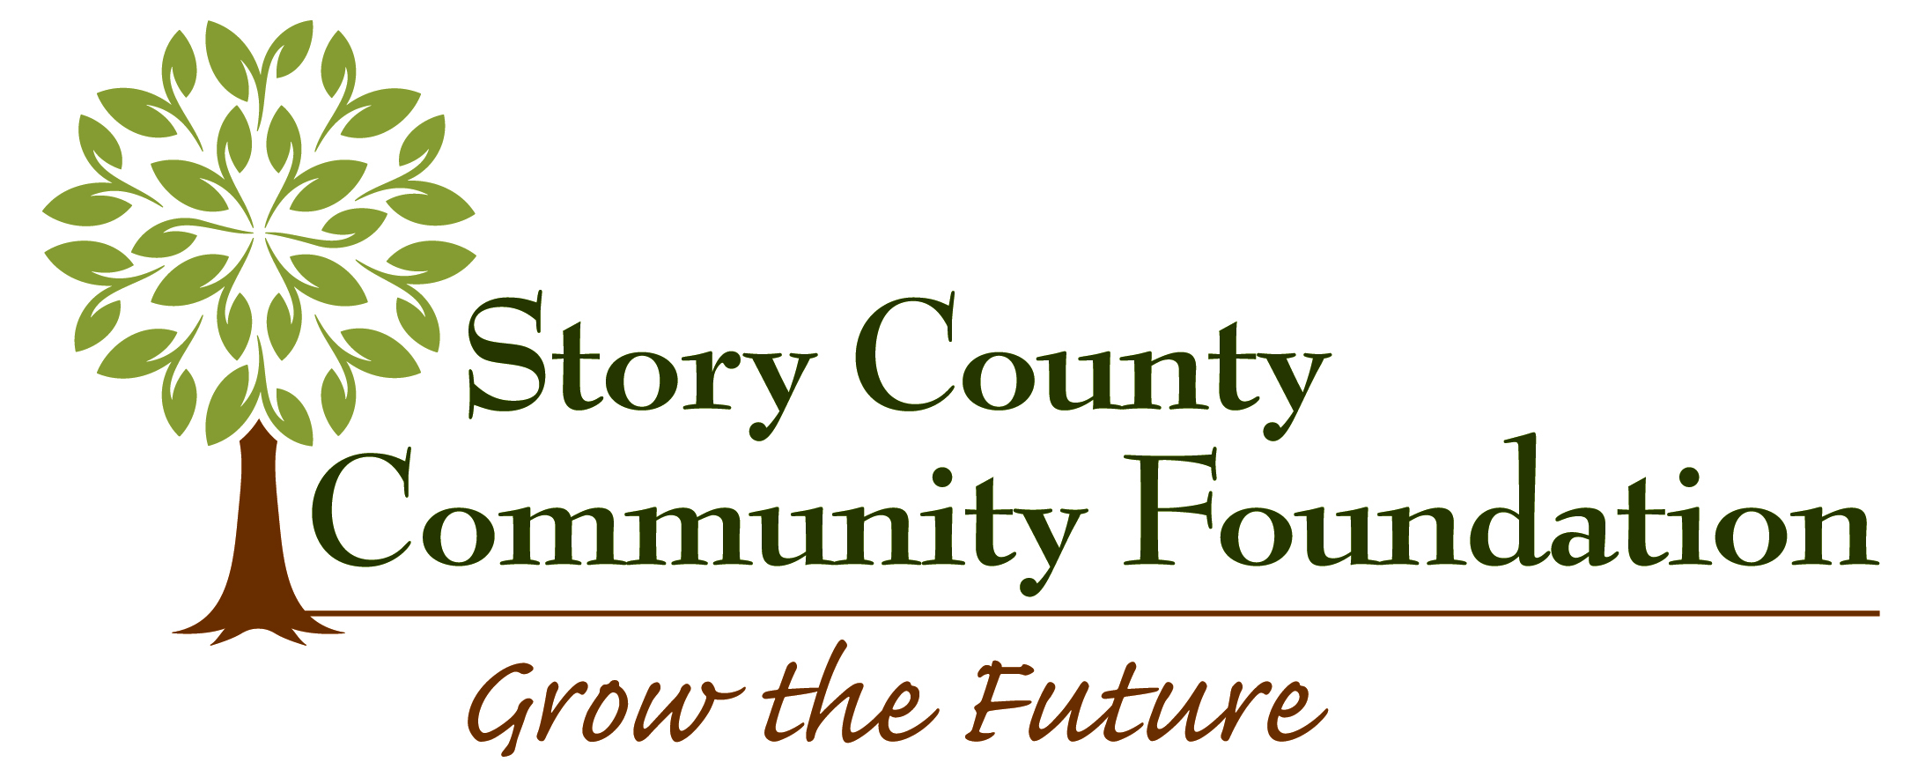
Capacity Building Grant Application

Applications must be submitted electronically
between January 1 and August 31, 2020
Grant requests of up to $2,500 will be considered

Organization:
Contact person:
Position in organization:
Applying agency address:
City, State, Zip:
Phone number:
Email:
Type of applying organization: 501(c)(3) non-profit organization
local government: type
Federal tax identification number of organization:

Fiscal sponsor information is only needed if different than the applying organization.
Name of fiscal sponsor (if different than applying organization):
Federal tax identification number of fiscal sponsor:
Fiscal agency address:
City, State, Zip:
Phone number:
Email:

Project name:
Amount being requested from the Story County Community Foundation: $
Matching funds (if any): $
Total cost of project: $
Brief description of organizational need addressed by grant:

Brief description of anticipated results of the project and how it impacts the future of the
organization:

Brief description of how this grant would help grow your fund(s) at SCCF:
Project timeline:

Board commitment to the project, both financially and in terms of participation:
Project budget: Include other sources of funding and the amount requested from SCCF. Include only costs pertinent to the project. Specify how the SCCF funds would be used.
If your request is for an education purpose, explain how newly obtained information will be disseminated within your organization.

Required Documents:
- A list of the organization’s board of directors with contact information and email addresses

Please submit your completed application with the required documents in one pdf packet via email to jendieter1@gmail.com.

The project representative certifies that he/she is authorized to represent the organization applying for a grant and that the information contained in the application is accurate. He/she agrees that if a grant is awarded to the organization:

- The grant will be used for the purpose outlined in the grant award letter and may not be expended for any other purpose without prior written approval from the Story County Community Foundation
- The Story County Community Foundation has received nothing of material value in exchange for the grant
- Information about the organization and the grant may be used by the SCCF in any published materials

________________________________________________ ___________________________
Authorized Project Representative Date

Printed name:

For more information on the Capacity Building Grant application and funding process, please contact
Jennifer Dieter, Grantmaking Committee Chair at jendieter1@gmail.com.

